🧪 🔥 LAB: Variable Scope & Return Status in Shell Scripting
This is a very important Bash concept used in:
- Automation
- Functions
- Error handling
- DevOps scripting
You’ll learn:
✅ Global vs Local variables
✅ Function behavior
✅ Return status ($?)
✅ Script success/failure logic

⚙️ Step 1: Create script
nano scope.sh

✍️ Step 2: Paste this script
#!/bin/bash

# Global variable
name="Anamika"

echo "🌍 Global variable outside function: $name"

# Function
test_scope() {

# Local variable
local name="DevOps Learner"

echo "📦 Local variable inside function: $name"

return 0
}

# Call function
test_scope

# Check return status
echo "✅ Function return status: $?"

# Global variable remains unchanged
echo "🌍 Global variable after function: $name"
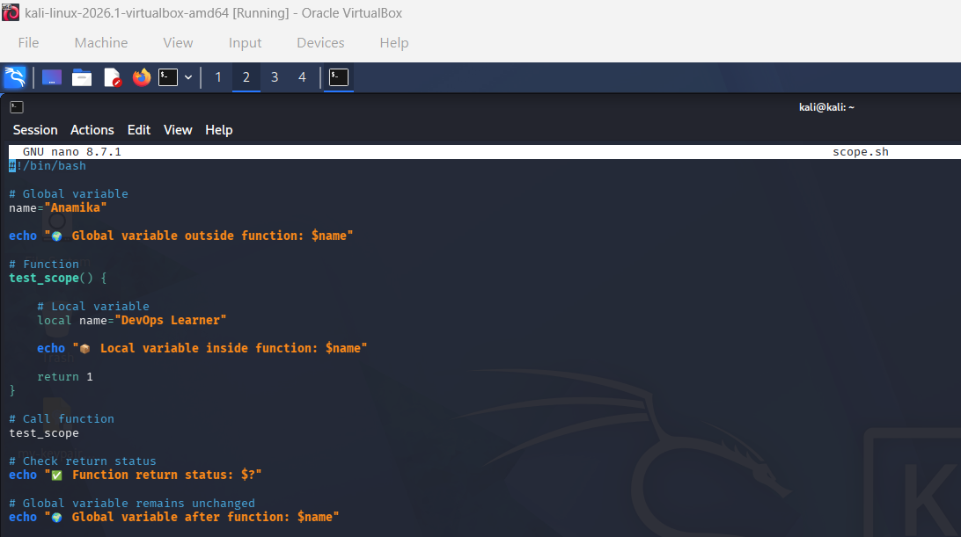

🔐 Step 3: Give permission
chmod +x scope.sh

▶️ Step 4: Run script
./scope.sh

🎯 Expected Output
🌍 Global variable outside function: Anamika
📦 Local variable inside function: DevOps Learner
✅ Function return status: 0
🌍 Global variable after function: Anamika
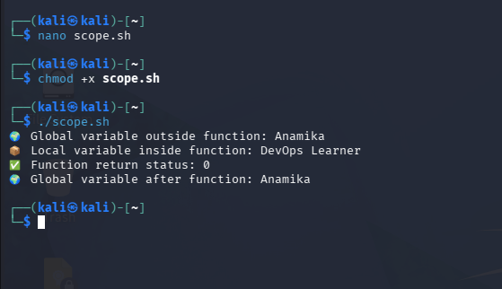

🧠 Understanding Variable Scope
🌍 Global Variable
name="Anamika"
👉 Accessible everywhere in script

📦 Local Variable
local name="DevOps Learner"
👉 Exists ONLY inside function

🔍 What happened?
Inside function:
DevOps Learner
Outside function:
Anamika
👉 Local variable did NOT overwrite global variable

🚨 Step 5: Test failure return status
Modify function:
return 1
Run again.
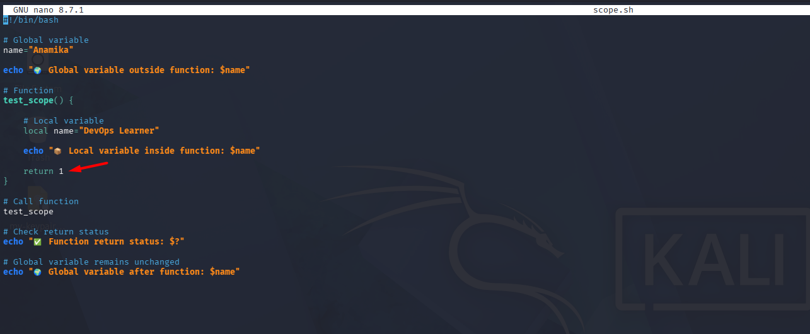

🎯 New Output
✅ Function return status: 1
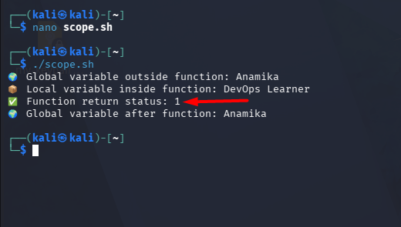

🧠 What return status means
Status | Meaning
0 | Success ✅
1+ | Failure/Error ❌

⚡ Real-world DevOps usage
Return status is used in:
- CI/CD pipelines
- Monitoring scripts
- Automation workflows
- Health checks

🔥 Advanced mini challenge
Add this:
if [ $? -eq 0 ]
then
echo "🚀 Script successful"
else
echo "❌ Something failed"
fi

🎤 Interview-ready answer
“Global variables are accessible throughout the script, while local variables exist only inside functions. Return status helps determine whether commands or functions executed successfully.”

🚀 Pro Tip
Always check:
echo $?
👉 after important commands in automation scripts.

